Closest Points Correspondences VS. Normal Directions Correspondences
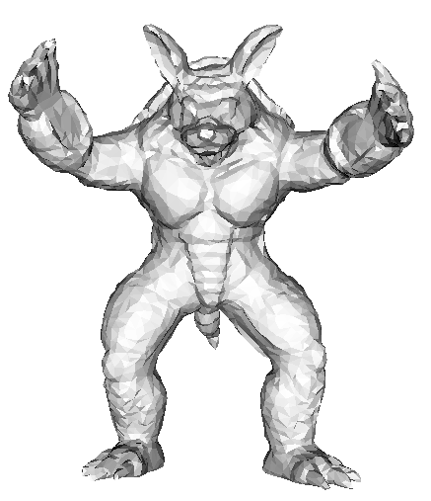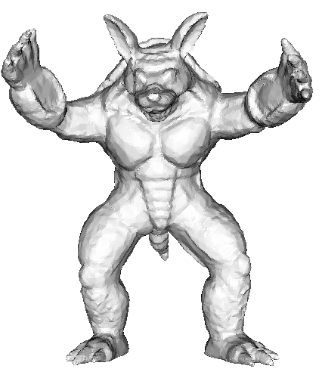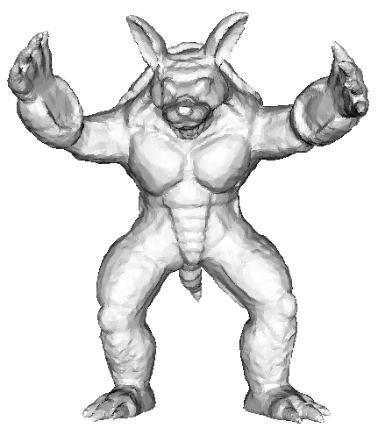
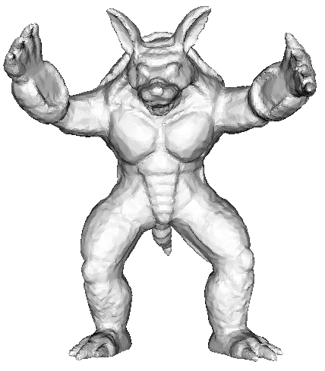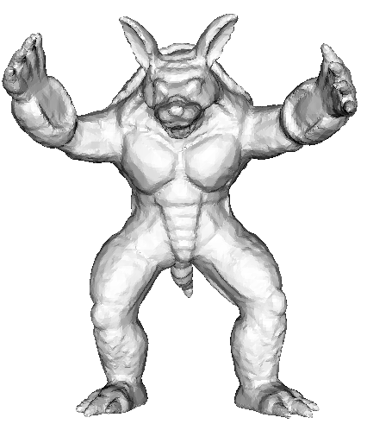
Original mesh (5002 vertices) Deform to fit_ iteration 1 Deform to fit_ iteration 2
Comparisons with different resolutions. The top row is the normal direction cores., and the bottom row is the closest points cores..
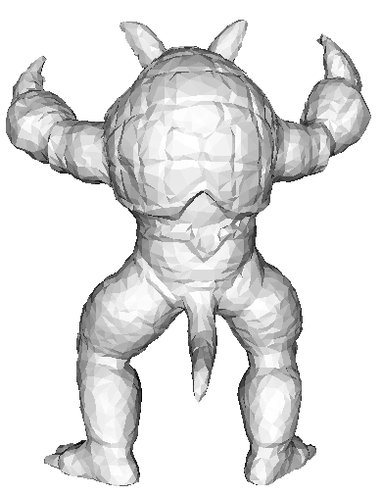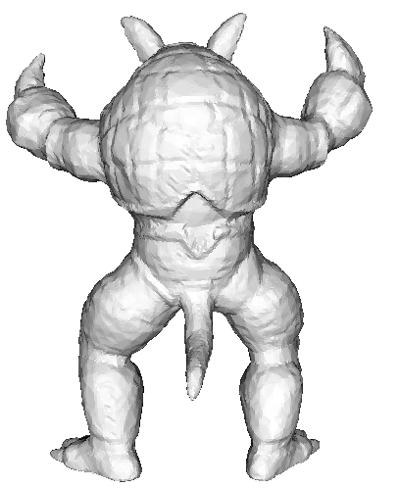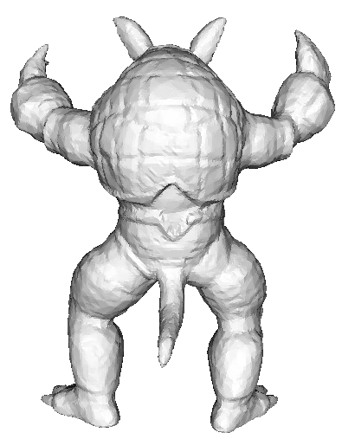
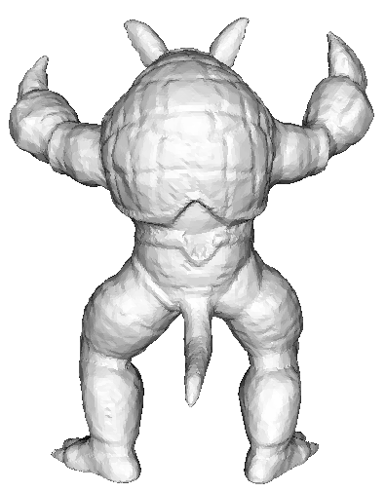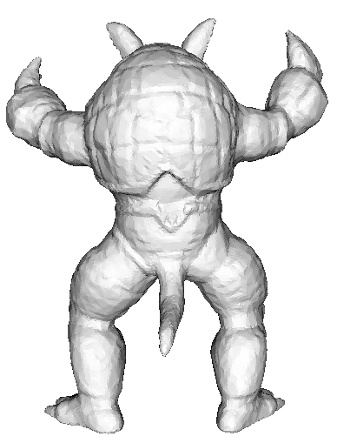
Original mesh (5002 vertices) Deform to fit_ iteration 1 Deform to fit_ iteration 2
Comparisons with different resolutions. The top row is the normal direction cores., and the bottom row is the closest points cores.
Note: the angle bounds are in [30, 90] for all the results.

 | Max distance | Mean distance
Closest Point Corres. iteration 1 | 0.004386(0.009068) | 0.000099(0.000333)
Normal Direction Corres. iteration 1 | 0.003887(0.008714) | 0.000076(0.000257)
Closest Point Corres. iteration 2 | 0.003951(0.008727) | 0.000091(0.000318)
Normal Direction Corres. Iteration 2 | 0.003401(0.005668) | 0.000070(0.000242)
The two directions Hausdorff distances (compared with the dialog line of boxing box).
0.005699: the Hausdorff distance from the result to the original mesh
(0.017363): the Hausdorff distance from the original mesh to the result

